Do you need more assistance?

**FOOD BANK OF ALASKA CAN HELP!**

SNAP

Apply for SNAP (food stamps) or renew/recertify your application. Our SNAP Outreach Team can answer your questions or help you apply.

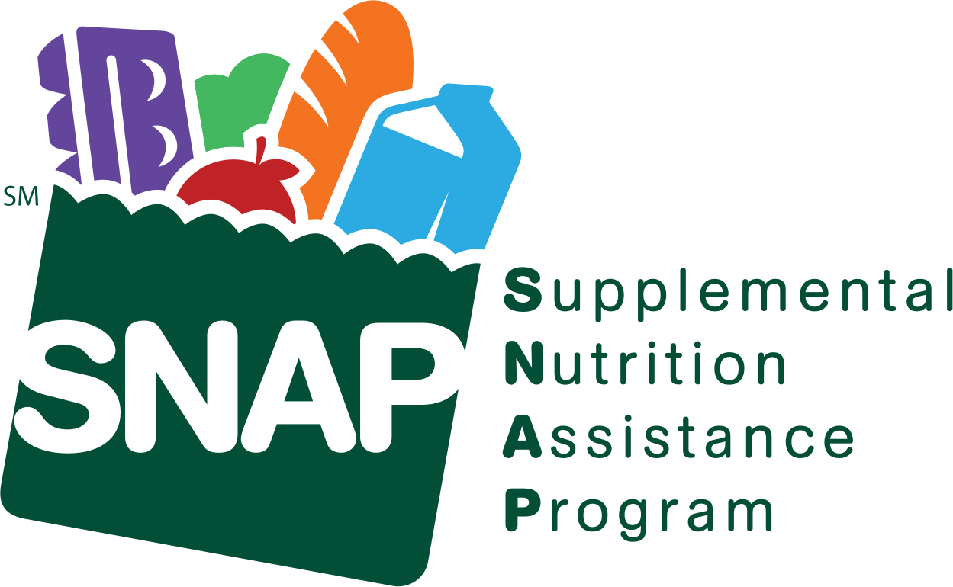Contact one of our SNAP Specialists today!

**Email:** [**SNAP@foodbankofalaska.org**](mailto:SNAP@foodbankofalaska.org)

**Text: SNAP to 907-891-8913**

FoodPantries

# Visit one of the food bank's partner food pantries near you. Find pantries close to you by:

# Visit FBA's Statewide Resources page: [**www.foodbankofalaska.org/help/**](http://www.foodbankofalaska.org/help/)**statewide-resources/**

# Type in your zip code to see locations and contact information for pantries closest to you.

Anchorage Mobile Food Distributions

Visit our Calendars & Schedules page to find mobile food distributions near you: [**www.foodbankofalaska.org/for-agencies/calendars-schedules/**](http://www.foodbankofalaska.org/for-agencies/calendars-schedules/)

Medicaid Assistance

Medicaid renewals began April 1, 2023. To make sure you’re contact information is up to date visit **heath.alaska.gov/dpa/pages/Medicaid/Medicaid-renewals.aspx**

Free Legal Services

For free legal assistance with your public benefits, visit **alsc-law.org** and click “Get Help Now” or you can call them at **888-478-2572A picture containing graphics, cartoon, clipart, graphic design
**.

www.foodbankofalaska.org

find food bank of Alaska on: